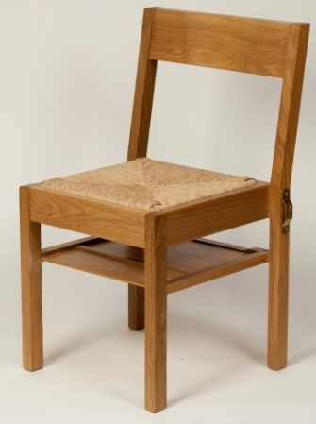
Chair donation Online Form

Gift Aid it. Charities can reclaim tax paid on donations made by individual taxpayers under the Gift Aid scheme. The donor must pay an amount of Income Tax and / or Capital Gains Tax within the tax year at least equal to the tax repayment claimed on their donations by all the charities and community amateur sports clubs to whom the donor donates in that tax year. Other taxes such as VAT and Council Tax do not qualify.
Gift Aid and Contact Form
Name ..................................................................................................
Address................................................................................................
……………………………….…………………………………………………………….…………
Postcode ................................ Date ...................................

I am a UK taxpayer intending tax to be reclaimed on the enclosed donation under the Gift Aid scheme.
I have read and understood the Gift Aid guidance above.
Signature ....................................................................................
Donation £ .................................

We will also have a folder in church in which – but only if you agree – we will display a copy of your certificate e.g. if the donation is in memory of a person or event, or if you would like to be publicly associated with the provision of the new chairs.
Please indicate below (a) if you want your certificate displayed in the folder and,
if so (b) what wording you would like it to contain.

(a) ☐ I would like a certificate
(b) ☐ I would like a copy of the certificate in the folder in church

The wording I would like on the certificate is

…………………………………………………………………………………….……………………………………………………………

………………………………………………………………………………………………………………………………………………….

Please put your form and payment onto the collection plate or give it to the Treasurer (Roger), Chair donation Administrator (Alan), Church Warden (Annie or Mat), Vicar (Stephen), member of the PCC etc.

